# MoviesDB

MoviesDB is a movie library management application.

## Model

The application enables to store and retrieve the following information about the movies:

* Title (Required field, max length: 200)
* Director’s name (max length: 100)
* Release date (a valid date, cannot hold a future value)

## Supported Use Cases

### List Movies

Retrieve all the persisted movies’ information, and display it in a table to the user:

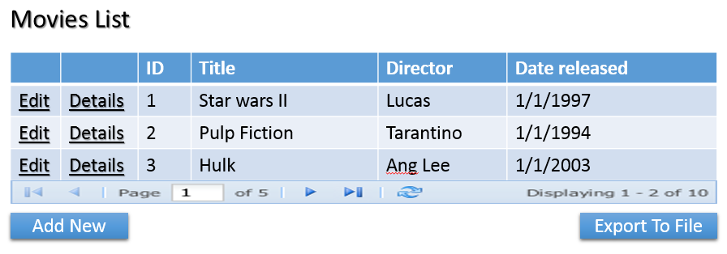

The data will be displayed to the user in pages. I.e., not all movies are retrieved from the database, but as pages of a predefined size. The page size should be modifiable in the application’s configuration file.

### Add a New Movie

The user can add a new movie to the movies repository:

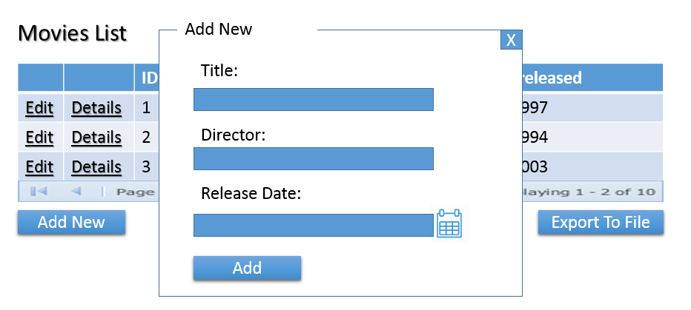

The user’s input should be validated against the rules defined in the Model description.

### Edit an Existing Movie

The user can edit details of an existing movie. The user interface is similar to the entry of a new movie.

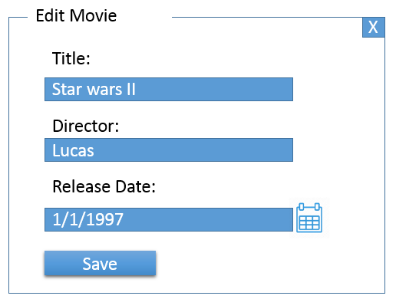

### Display Movie’s Details

The user can see details of a movie:

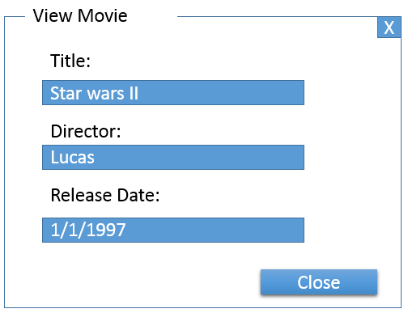

This information is read only.

### Export

The user can import movies information into a file. The file will hold the data in the JSON format.

## Implementation Guidelines

* MoviesDB should be implemented as a singe-page ASP.Net MVC application.
* Any relational database can be used for data storage. Also, any O/RM, or other means of working against the database, can be used.
* You are encouraged to use any client side UI frameworks you are comfortable with.